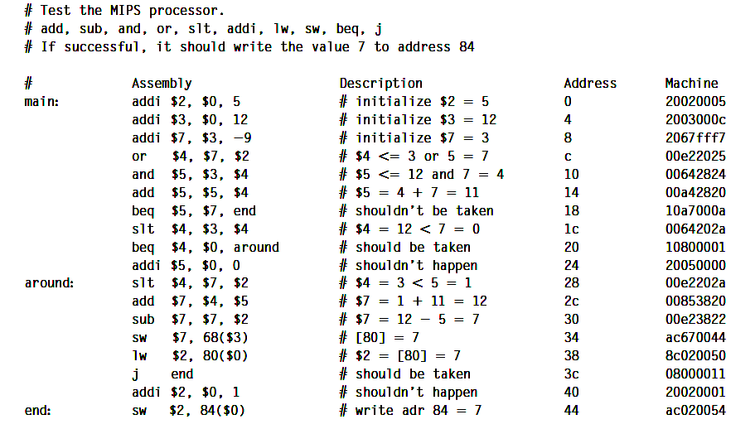

This is the code for the testbench to run. It has to write the value of 8 into Memory location 84.